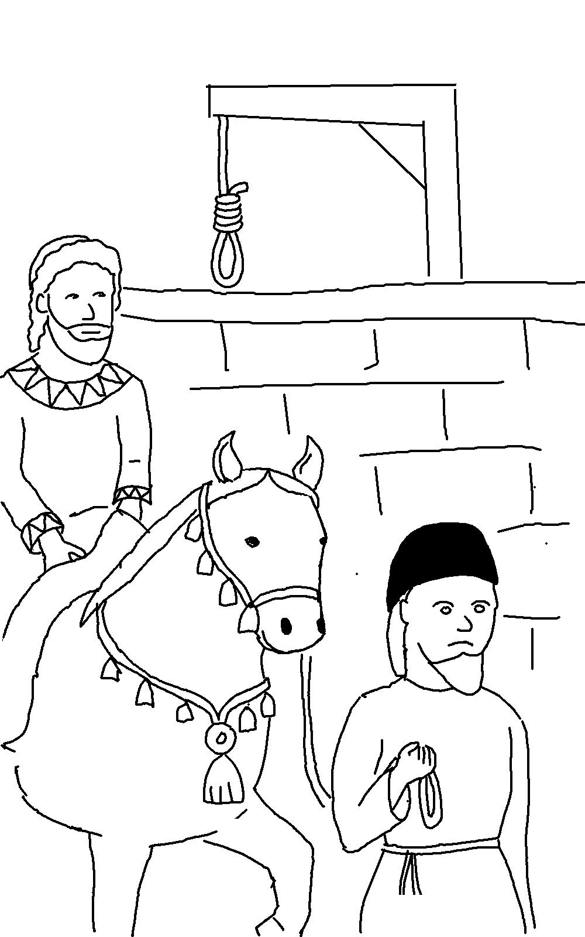
If _ _ _ is for us, who can ever be
_ _ _ _ _ _ _ us?
Romans 8:31_{NLT}

